DISC DEXPI Symbol Definition Requirements
Prepared for
DISC DEXPI Group
Prepared by
Pedersen, Tonia

Table of Contents
Change Record 3
Table of Contents 4
DISC DEXPI Profile Symbol Definition 5
Overview 5
Symbol Definition Overview 5
Symbol Validation Overview 5
Symbol Definition and Identity Requirements 6
Additional Definition Requirements 6
Unique Symbol Reference 6
NodePosition Types 7
Node Direction 7
Label Attribute Definitions 7
Symbol Variants 7

DISC DEXPI Profile Symbol Definition

Overview
The P&ID is a detailed graphical representation of the process flow and interconnection of the involved components, including piping, equipment, valves, instrumentation, and other process components.
Within the DISC DEXPI project the content of the P&ID has been transcribed into a digital format as prescribed by the DEXPI standard through the detailed use of symbol definitions and their mapping, either directly or as the result of project criteria to DEXPI class types or subtypes.
The detailed symbol definitions are then used when validating the DEXPI file to ensure correct symbol/class usage and connectivity. For validation it is imperative that the definition of the symbol is given using the DEXPI standard definitions to ensure that the explicit interconnectivity towards the DEXPI model is maintained and maximized during the validation process.

Symbol Definition Overview
A Profile/Symbol defines:
- The graphical appearance of a symbol
- Its symbol variants and variant-selection rules
- The node positions allowed for connections
- The rules for rotation and mirroring
- The mapping between symbols and DEXPI class elements
- The label templates and their placement
- The mapping between the label attributes and the DEXPI class elements

Symbol Validation Overview
Symbol definitions are used when validating a DEXPI file to ensure that:
1. The instantiated symbol matches the intended class element.
2. The symbol variant selected in the drawing corresponds to the attribute/value condition in the DEXPI data.
3. The node connections comply with the declared node position types and min/max constraints.
4. The labels shown in the drawing follow the specified positions and attribute references.

Symbol Definition and Identity Requirements
The symbol definition and identity requirements are defined in detail in the DISCProfile. Each symbol is defined using the DEXPI standard definitions along with additional Profile model definitions (that are expected to be added to the DEXPI standard in a near release)
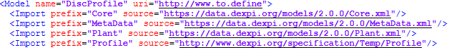
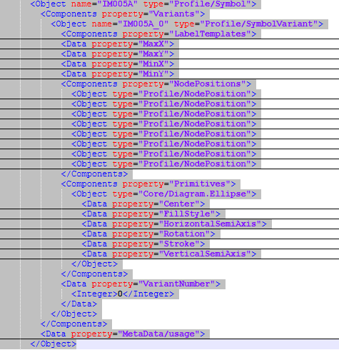

Additional Definition Requirements

Unique Symbol Reference
Each symbol must define a unique:
Symbol name (Object/@name at Profile/Symbol level)
SymbolVariant name (Object/@name under Variants)
These must be unique within the profile namespace and serve as the reference for validation.

NodePosition Types
The following NodePosition types are used within the validation of the DEXPI file:
- Auxiliary: node type to validate for correct connectivity between equipment types to support mechanical energy transmission
- Instrumentation: node type to validate for correct use of SignalConveyingFunctionSource/SignalConveyingFunctionTarget connection to SignalConveyingFunction
- Label: node type providing information on default label connection point
- Piping: node type to validate for correct use of PipingNode connection to PipingConnection element

Node Direction
Node direction (e.g., 180°, 0°, 270°) has been added assist automated drawing generation. Validation does not require direction checking.
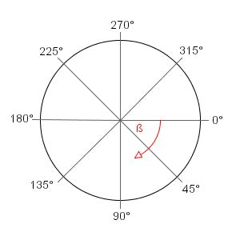
Figure 1: Connection line angle intercept value reference

Label Attribute Definitions
Label attributes are mapped towards class attribute references such that any label that is or can be referenced by a DEXPI class element must only contain attributes known to that class element.
DEXPI attributes are defined with an RDL reference.

Symbol Variants
Support of ‘intelligent’ symbols is built into the DISC DEXPI profile through the use of symbol variants and associated Condition requirements. Variant 0 is defined as the default variant where no information is given regarding the variant condition of the symbol.
Each set of conditions is given in a fixed list of values for the class type associated with the symbol.
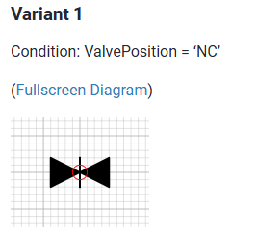
Figure 2: Variant 1 ValvePosition = 'NC'

